With the rising interest in flexible work options, many are turning to online job boards in search of remote opportunities. However, not all of these websites are legitimate, with some designed to scam job seekers.

Remote Work: What to Look Out For

To safeguard against potential scams, here are some essential tips to avoid job-related scams:

1. Research the Company

Before applying, take the time to delve into the company’s reputation. Check out reviews, their official website, and their presence on social media. If you can’t find information about a company, you should beware.

2. Avoid Paying for Job Listings

Remember, legitimate job opportunities are listed without charge. Any website that demands payment for access to listings should be viewed with suspicion. Many sites do have subscriptions that give you access to more jobs, but there is no reason to use these unless they provide a lot more than just job listings.

3. Guard Personal Information

Protect your sensitive information like social security numbers or bank details. Legitimate employers do not request this information during the initial application process.

4. Spot “Work from Home” Scams

Approach jobs that promise high returns for minimal effort or those that require payment for training or equipment with skepticism. Real employers will bear these costs, so don’t pay for “training”, or equipment deliveries.

5. Trust Your Instincts

If a job listing or website seems weird, it’s wise to trust your gut feeling and stay away.

So, while remote work presents a lot of advantages, it’s important to be careful when looking for jobs online.

Acing Your Interviews

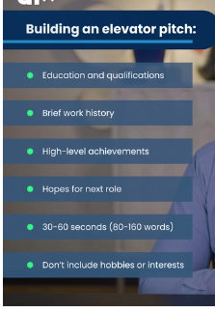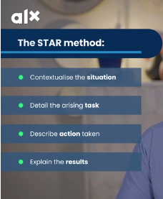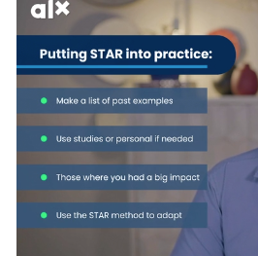

# **AI-Powered Interview Preparation**



Throughout this course, we’ve already looked at many different AI tools. A simple search will uncover even more. But have you noticed how many AI tools have paywalls at the end?

### Let me share some secrets with you…

**Secret 1:** How are all these paid AI tools built?

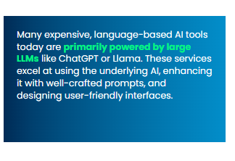Llama. These services excel at using the underlying AI, enhancing it with well-crafted prompts, and designing user-friendly interfaces.

**Secret 2:** What does this mean for us?

This understanding opens up exciting possibilities for us! 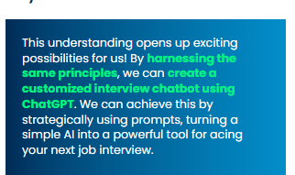job interview.

### Our Own Interview Chatbot



This prompt guide will help you **prepare effectively for interviews** by simulating role-plays, generating potential interview questions, and helping craft detailed, tailored responses. 

Category 1: Potential Interview Questions

Industry-Specific Questions

“Can you suggest some [INDUSTRY-SPECIFIC] questions that I might be asked during my interview for [POSITION OR ROLE], particularly related to [SPECIFIC ASPECT OF JOB OR COMPANY]?”

**Usage:** Use this prompt to generate questions tailored to the specific industry and role you are applying for, ensuring you are well-prepared for relevant queries.

Common Topic Questions

“What are some common questions on [TOPIC OR SKILL] that might be asked during an interview for [POSITION OR ROLE], and how can I tailor them to my [SPECIFIC EXPERIENCE OR SKILL SET]?”

**Usage:** This helps you anticipate questions based on common skills or topics related to the job and think about how to answer them effectively based on your background.

Unconventional Questions

“Can you provide me with some unconventional interview questions for assessing [SPECIFIC SKILL OR TRAIT], and how could these be integrated into the interview?”

**Usage:** Prepares you for more creative or unexpected questions that assess key skills or traits in unique ways.

Category 2: Crafting Tailored Responses

Structured Answer Preparation

“Based on the job description and my resume, help me craft a response to a common interview question using the CARL (Context, Action, Results, Learning) format, focusing on a specific example from my experience. [PASTE JOB DESCRIPTION AND RESUME]”

**Usage:** Guides you in preparing structured, impactful answers that highlight your achievements and what you’ve learned, directly linking your experiences to the job requirements.

Contextual Response Generation

“Given my background in [SPECIFIC FIELD] and the job requirements for [POSITION], help me develop an answer that effectively showcases my suitability for the role.”

**Usage:** Focuses on creating personalized responses that highlight how your specific experiences make you an ideal candidate for the position.

Category 3: Role-playing Interview Situations

Real-time Interactive Interview Simulation

“Act as an interviewer for the [SPECIFIC ROLE] position. Start by asking me an interview question based on the job description. After I answer, provide feedback, then ask the next question based on my response. Continue this process to simulate a real interview.”

**Usage:** This prompt directs ChatGPT to engage in a dynamic and interactive interview session where it acts as the interviewer, posing questions and providing feedback on your answers in real-time, mimicking the flow of an actual interview.

Progressive Role-play with Feedback

“You are a hiring manager interviewing me for [SPECIFIC ROLE] at [COMPANY]. Begin the interview by asking a question related to my experience as outlined in my resume. After I respond, offer brief feedback or follow-up based on my answer and proceed with the next related question.”

**Usage:** Enhances the interview practice by creating a situation where ChatGPT not only asks initial questions but also bases subsequent questions on your responses, providing feedback along the way to simulate a real-world interview scenario effectively.

[Back](https://intranet.alxswe.com/concepts/105910?project_id=101310)

Top of Form

 Mark as complete

Bottom of Form

Copyright © 2024 ALX, All rights reserved.



AI Brings New Job Opportunities

There are many companies looking for **“data annotators”**. This involves either **chatting to AI models, reading past conversations, or scoring how well models answered** a specific question. These jobs normally offer a decent hourly rate. As you go through some of these job-searching platforms, search for data annotator positions, and apply. Your new knowledge of AI and LLMs you learned in AiCE are quite handy for this type of work.  
  
Below are some great **platforms offering remote, flexible, and freelance job opportunities**:

FlexJobs

[FlexJobs](https://www.flexjobs.com/) is a premier platform for remote, flexible, and freelance job opportunities, featuring curated job listings, career coaching, skill testing, and regular webinars.

We Work Remotely

[We Work Remotely](https://www.weworkremotely.com/) offers a diverse array of remote job listings across various categories, along with company profiles for a comprehensive understanding of potential employers.

NoDesk.co

[NoDesk.co](https://www.nodesk.co/) serves as a resource hub and job board for long-term remote work opportunities.

Upwork

[Upwork](https://www.upwork.com/) connects professionals with freelance opportunities in a multitude of fields.

Remotive.io

[Remotive.io](https://www.remotive.io/) features remote job listings for both long-term positions and freelance work.

TrulyRemote.io

[TrulyRemote.io](https://www.trulyremote.io/) specializes in job listings for fully remote positions.

Working Nomads

[Working Nomads](https://www.workingnomads.co/) curates remote job listings tailored for digital nomads, offering both freelancing and long-term job opportunities.

Jobpresso

[Jobpresso](https://www.jobpresso.co/) is a job board for remote work, featuring longer-term opportunities. It caters mostly to US and Canadian citizens, but also lists “Worldwide” jobs.

Indeed

[Indeed](https://www.indeed.com/) is an extensive job search engine that includes remote positions. While not exclusive to remote jobs, you can filter to find “Remote Only” opportunities.

LinkedIn

[LinkedIn](https://www.linkedin.com/) is a widely used job platform that offers a range of long-term job opportunities, including local and remote positions.

Glassdoor

[Glassdoor](https://www.glassdoor.com/) provides job listings alongside genuine company reviews from current and former employees, offering insights into salary ranges for various job titles.